Tab 1
- Compile the Java code and create a JAR file (one.jar).
Step1 :
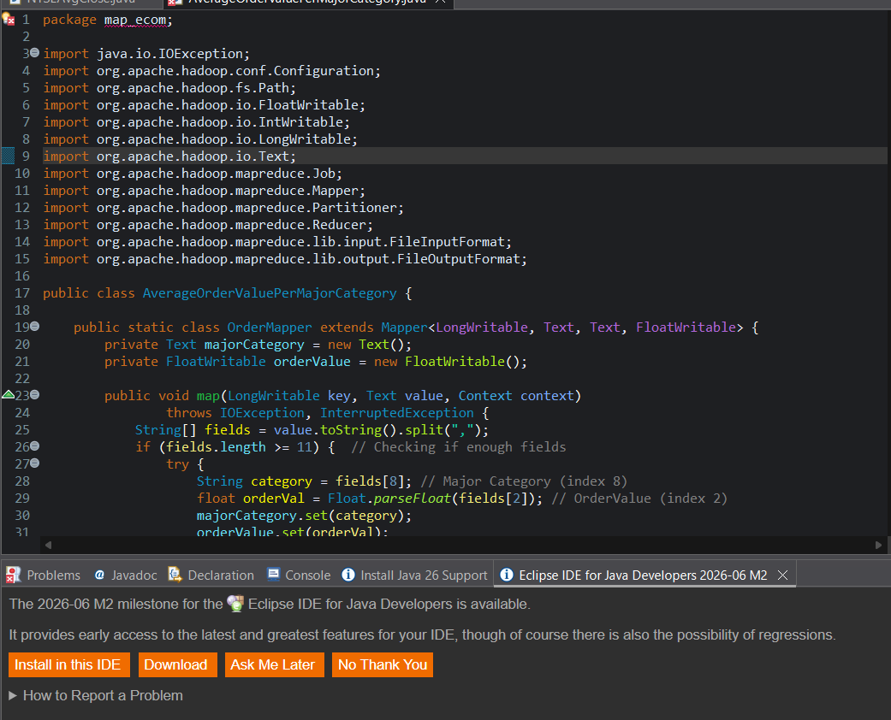

Step 2:
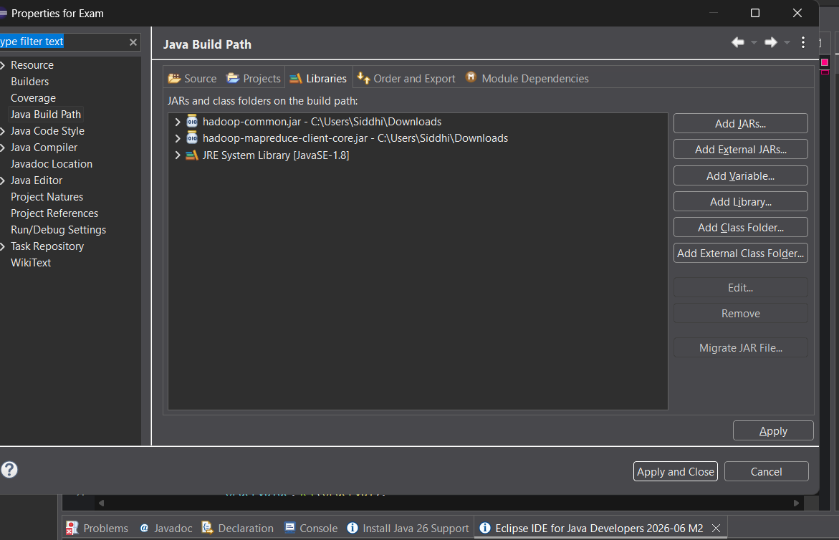

Step 3:
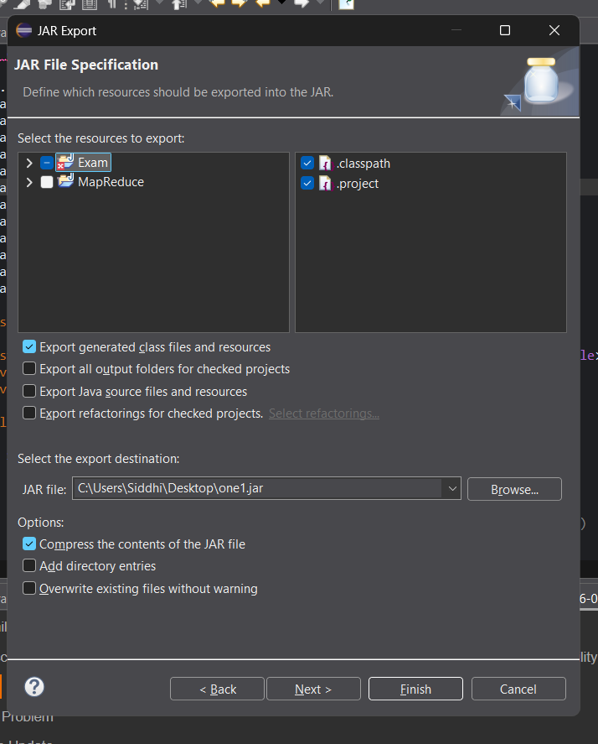

Step 4:
Upload jar file on FTP one2.jar
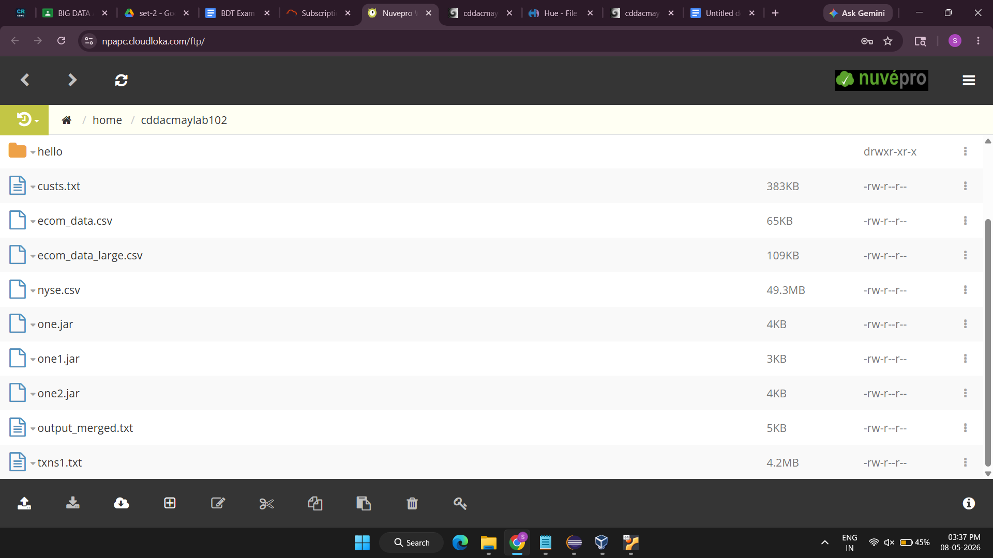

Run these on terminal
1 hadoop fs -ls
2. hadoop fs -mkdir new_input
3. hadoop fs -put ecom_data.csv /user/cddacmaylab102/new_input
4.jar tvf one2.jar
5. hadoop jar one2.jar mapreduce.AverageOrderValuePerMajorCategory new_input/ecom_data.csv /user/cddacmaylab102/output_new
6. hadoop fs -cat /user/cddacmaylab102/output_new/part-r-00000 | head -n 10

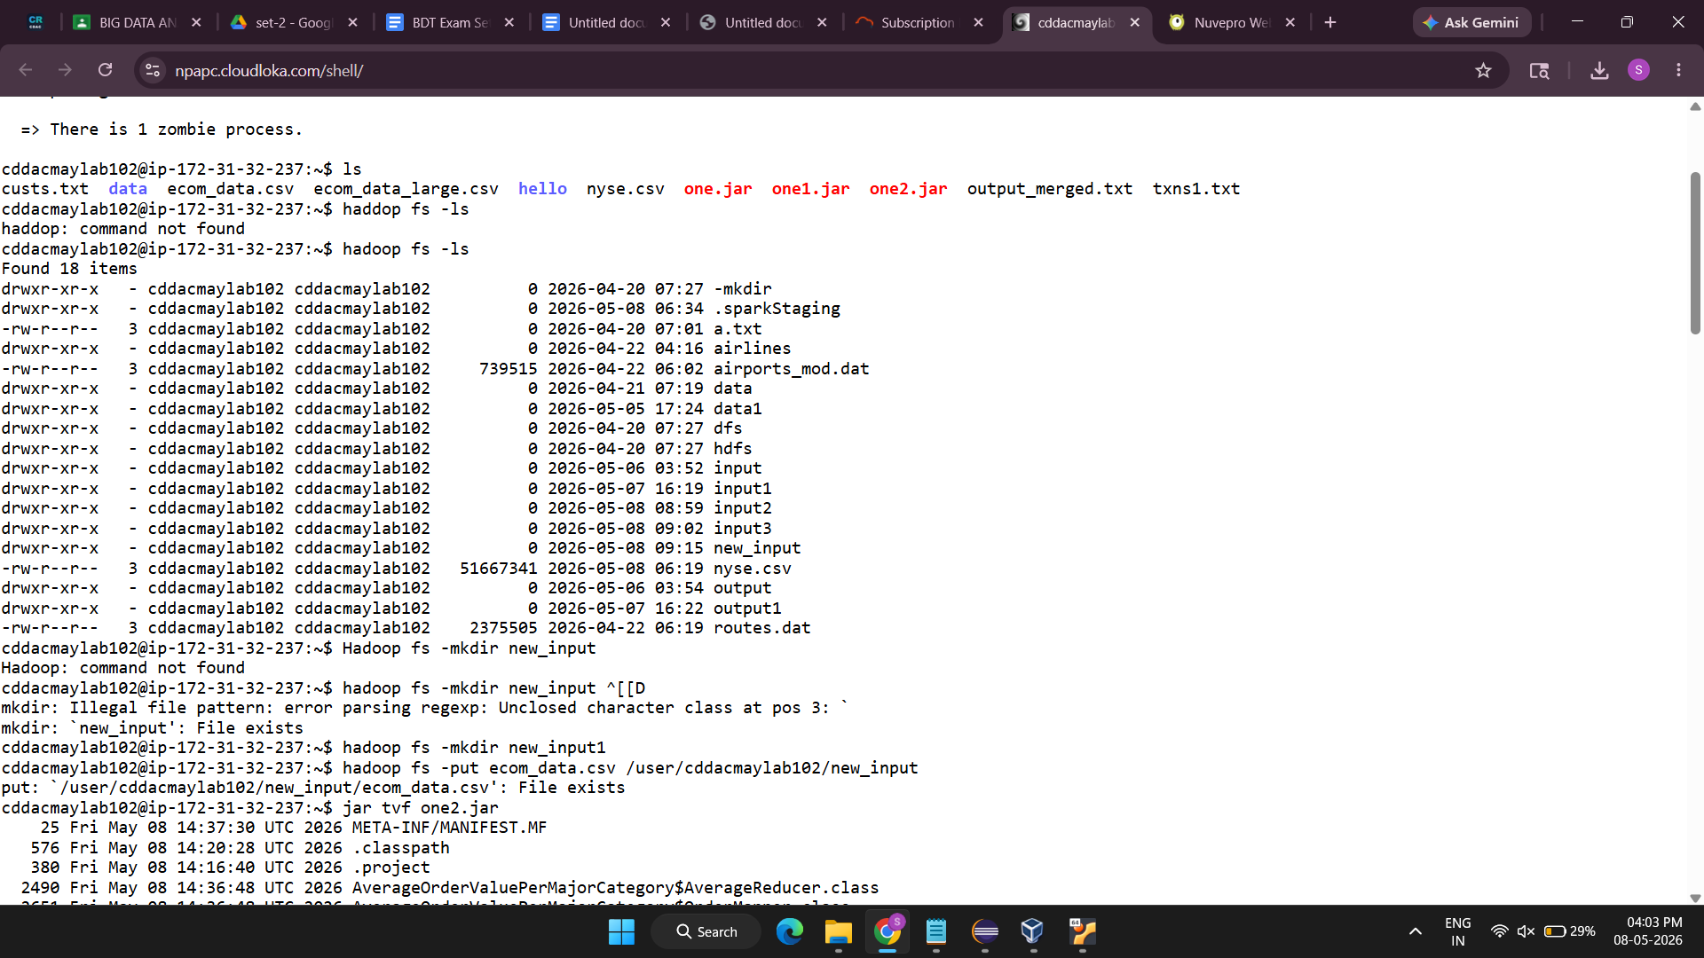

Tab 2
Q4 KAFKA
Created topic retail_topic_sid
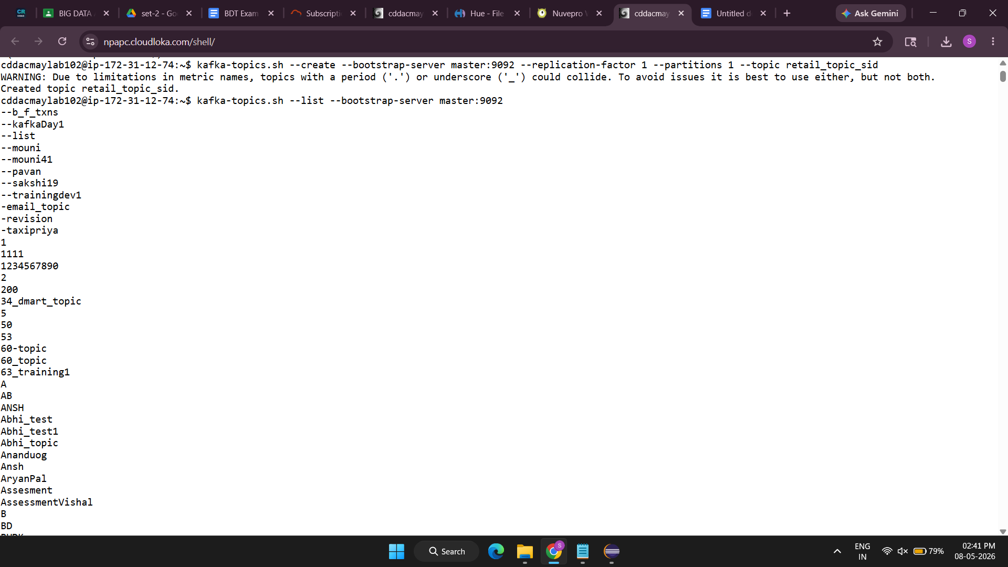
Created producer
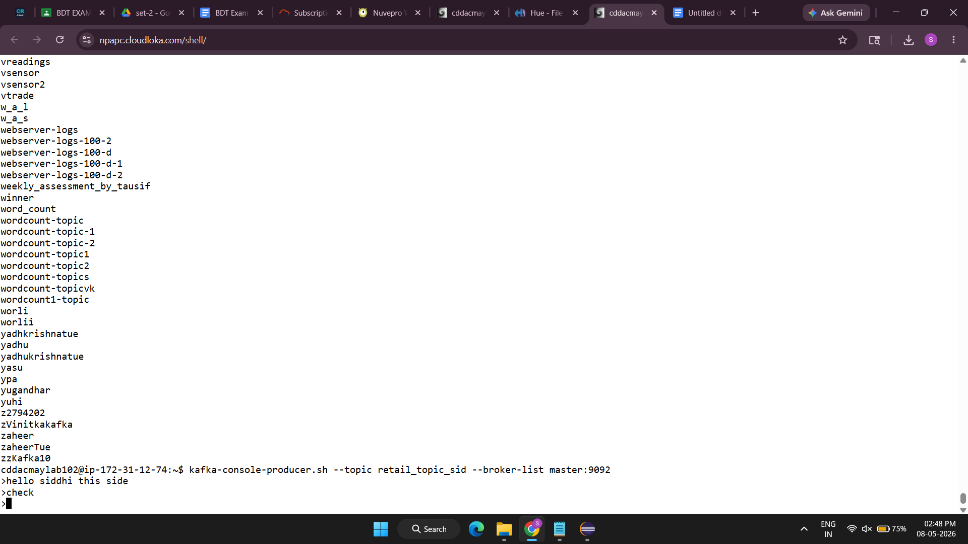

Created consumer
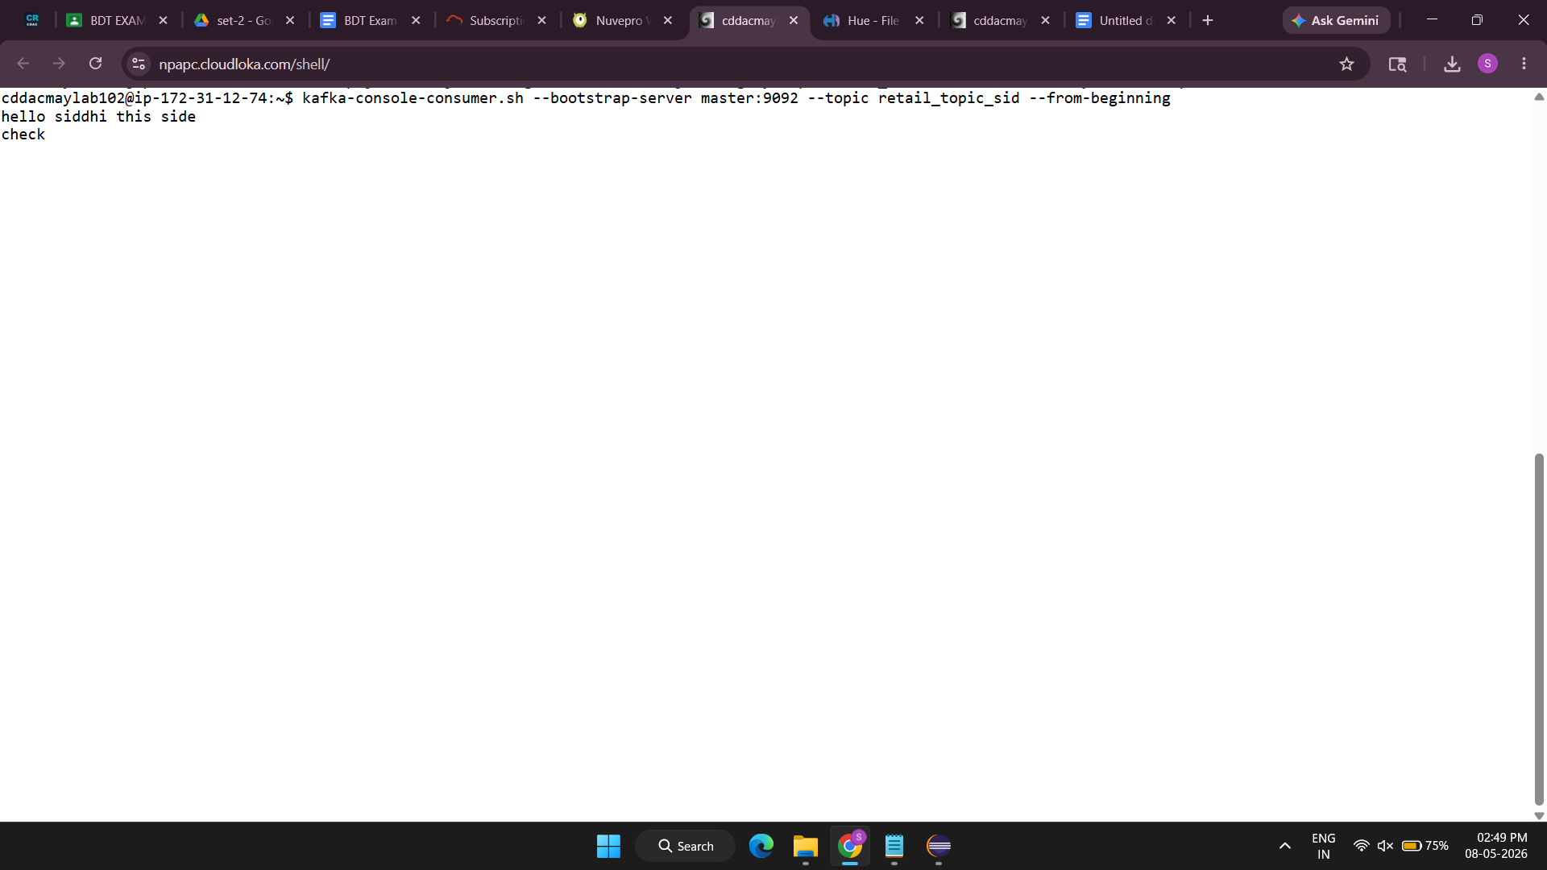

Tab 3
HIVE

1 tabel created
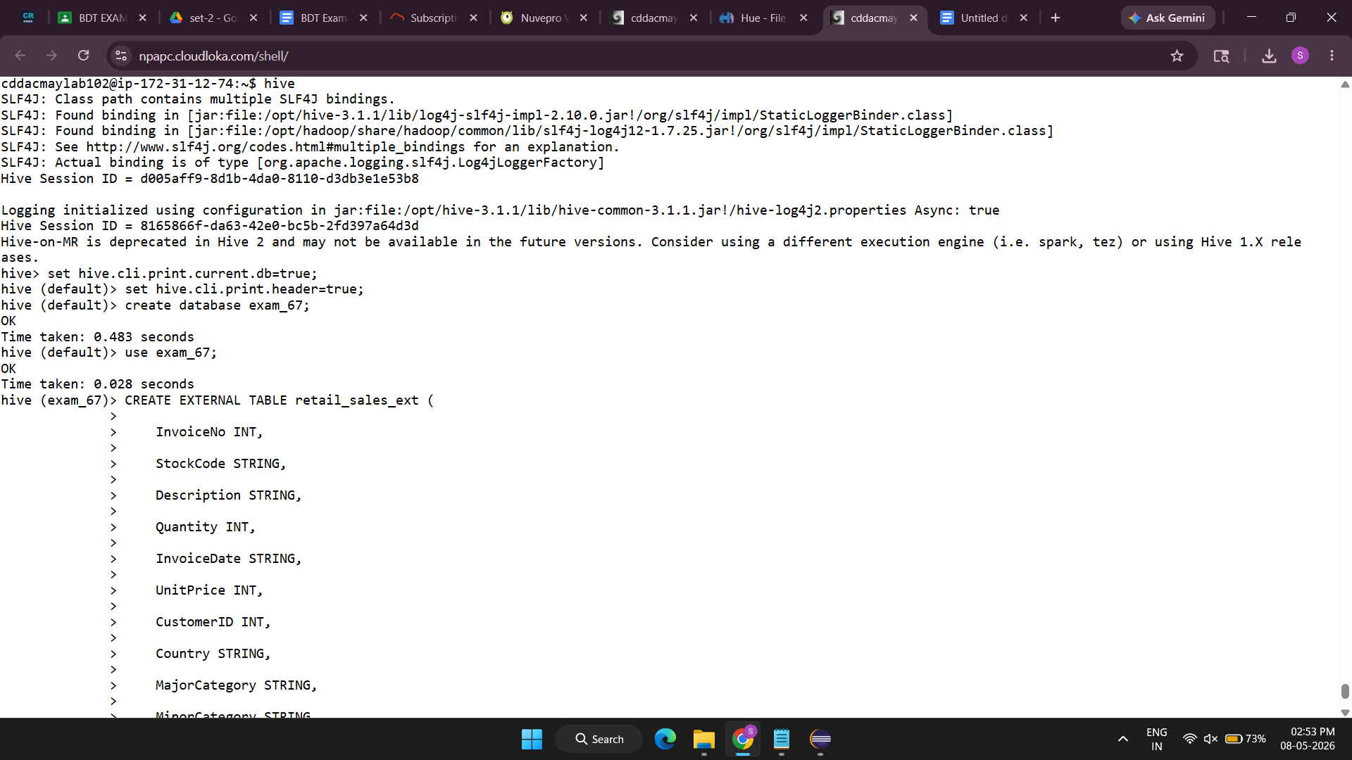
2 load data
LOAD DATA LOCAL INPATH '/user/cddacmaylab102/ecom_data.csv'
INTO TABLE retail_sales_ext;
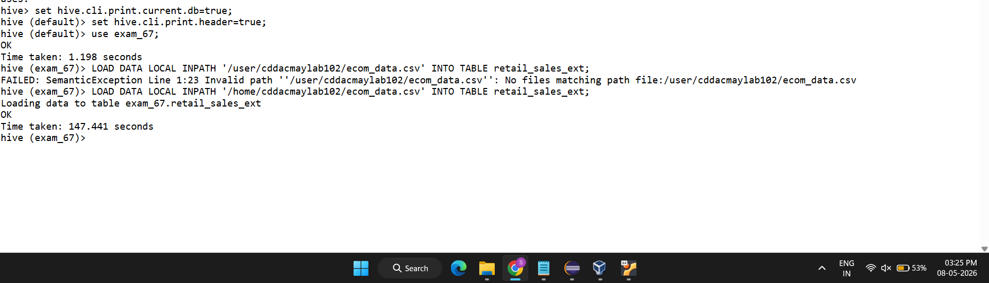

3 Write a query to find the maximum OrderValue for each Major Category.

SELECT
MajorCategory,
MAX(OrderValue) AS Max_OrderValue
FROM retail_sales_ext
GROUP BY MajorCategory;
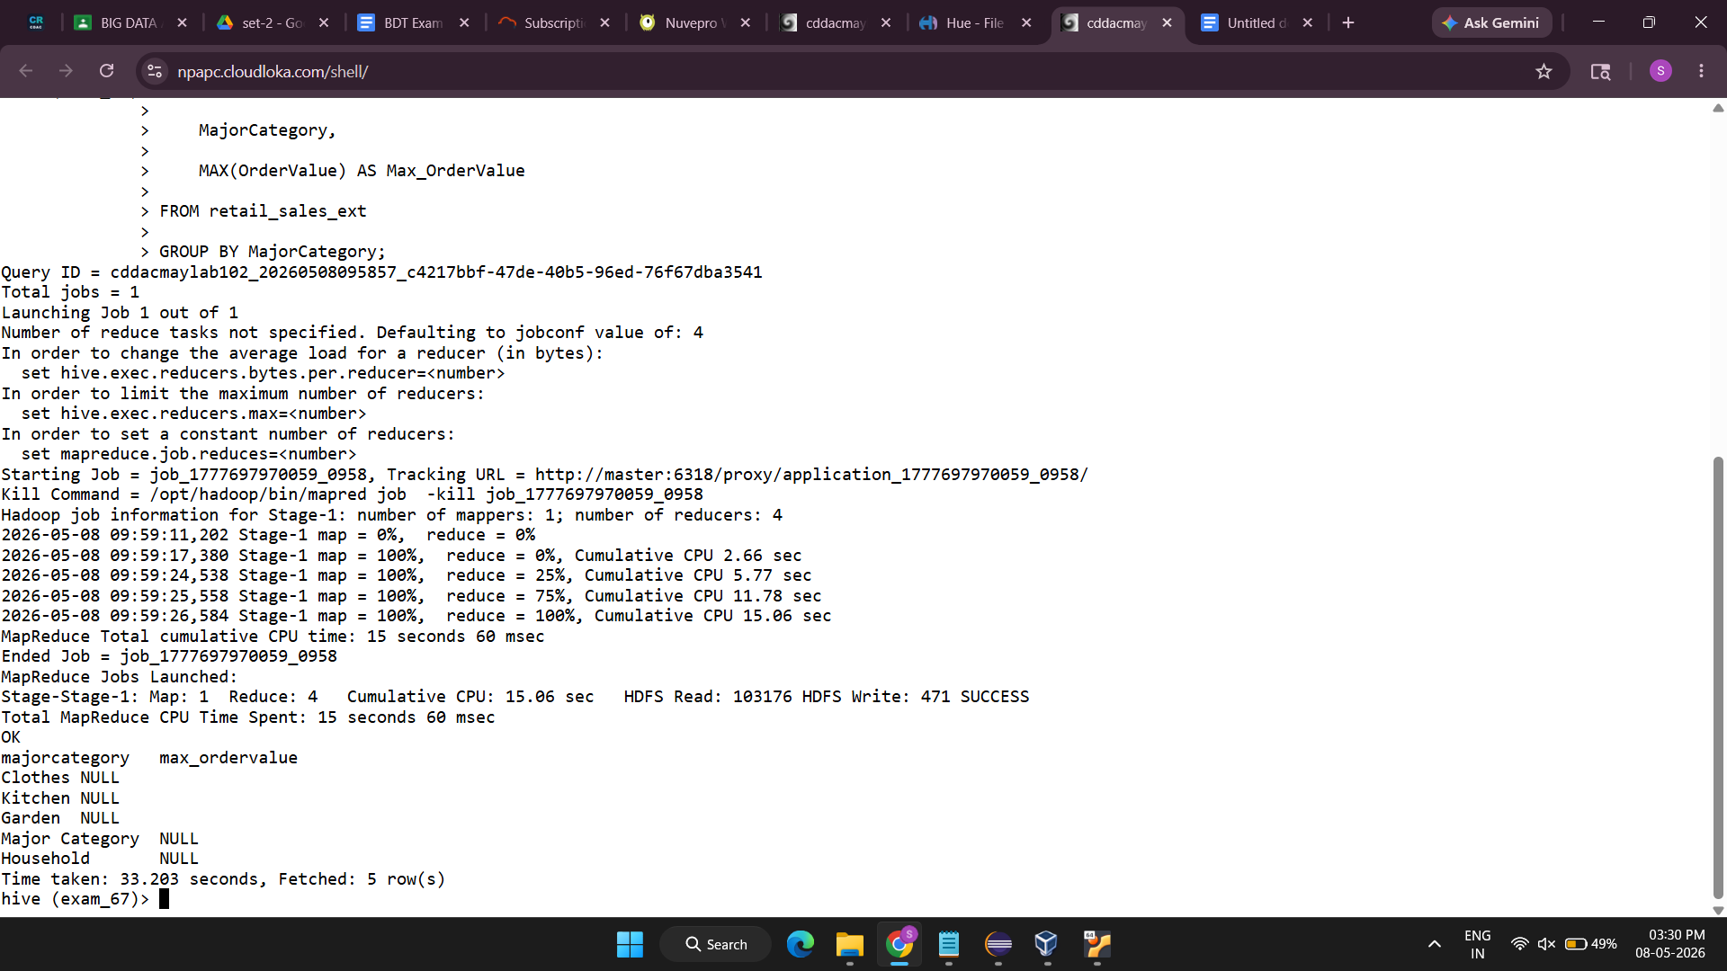

4.Create a partitioned table by Country and load the data accordingly. Also show the partitions created

CREATE TABLE retail_sales_partitioned (
InvoiceNo INT,
StockCode STRING,
Description STRING,
Quantity INT,
InvoiceDate STRING,
UnitPrice INT,
CustomerID INT,
MajorCategory STRING,
MinorCategory STRING,
OrderValue INT
)
PARTITIONED BY (Country STRING)
ROW FORMAT DELIMITED
FIELDS TERMINATED BY ','
STORED AS TEXTFILE;
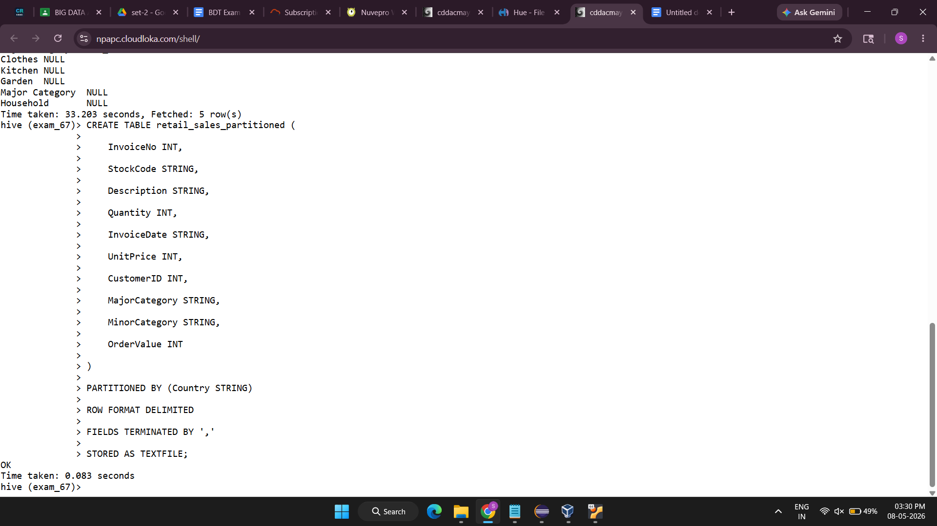

5. Write a query to find the top 5 Minor Categories with the highest number of orders using CTE.

WITH category_orders AS (
SELECT
MinorCategory,
COUNT(*) AS TotalOrders
FROM retail_sales_ext
GROUP BY MinorCategory
)

SELECT *
FROM category_orders
ORDER BY TotalOrders DESC
LIMIT 5;
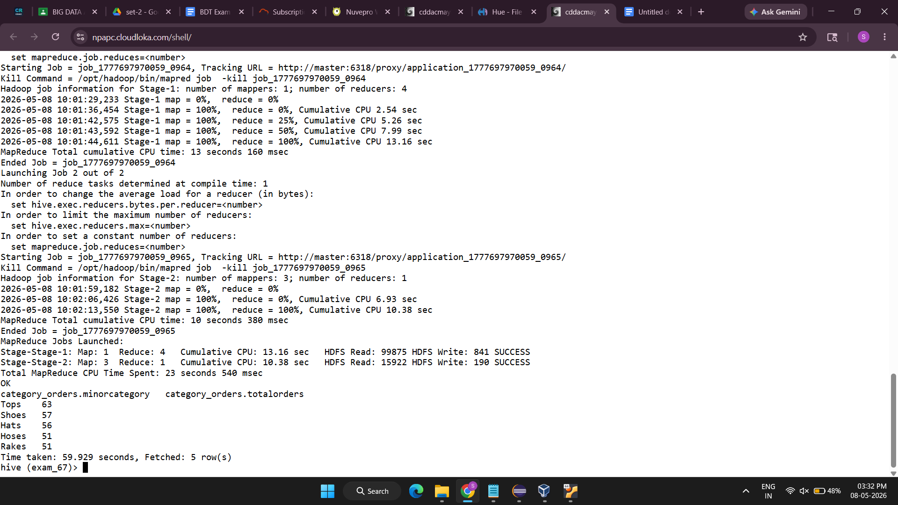
6.Create a managed table copying data from the external table

CREATE TABLE retail_sales_managed AS
SELECT * FROM retail_sales_ext;

-- Verify

SELECT * FROM retail_sales_managed LIMIT 10;

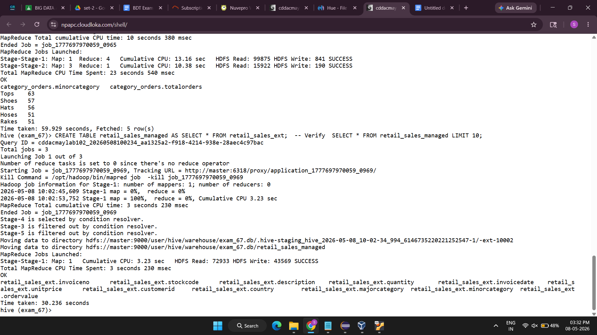

7.Create a new managed table retail_sales_orc stored as ORC format. ( marks)
Insert data into this ORC table from the existing managed table retail_sales_managed.
Fetch data from both retail_sales_managed and retail_sales_orc.
Compare the query performance between the two tables and comment on any differences observed.
ORC

CREATE TABLE retail_sales_orc (
InvoiceNo INT,
StockCode STRING,
Description STRING,
Quantity INT,
InvoiceDate STRING,
UnitPrice INT,
CustomerID INT,
Country STRING,
MajorCategory STRING,
MinorCategory STRING,
OrderValue INT
)
STORED AS ORC;
INSERT INTO TABLE retail_sales_orc
SELECT * FROM retail_sales_managed;
SELECT * FROM retail_sales_managed LIMIT 10;
SELECT * FROM retail_sales_orc LIMIT 10;
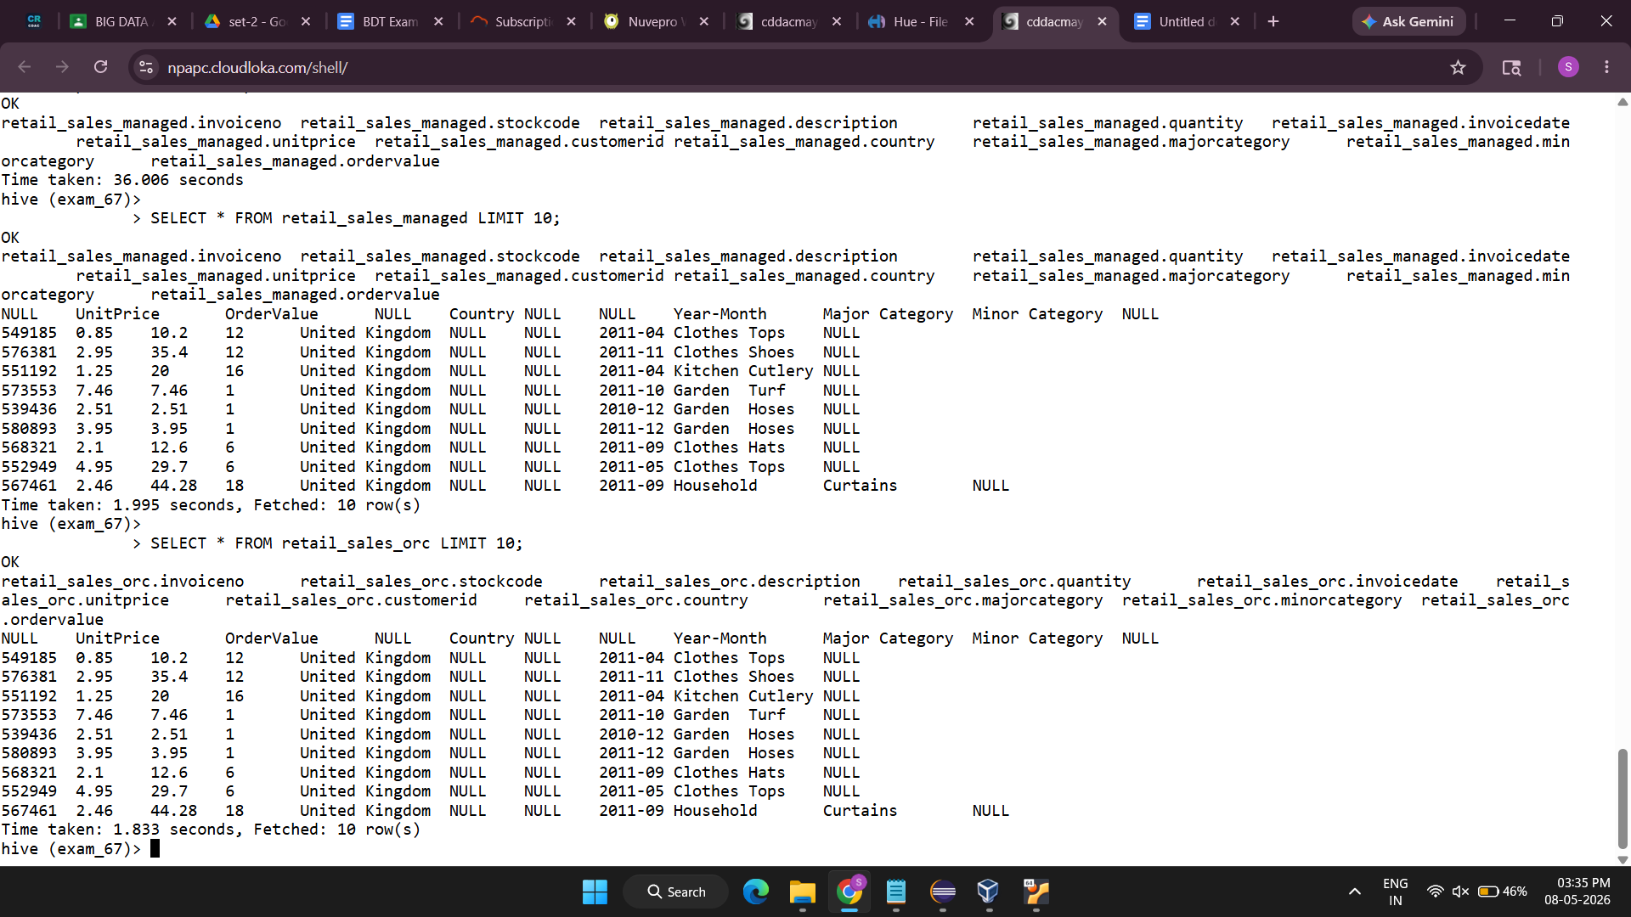
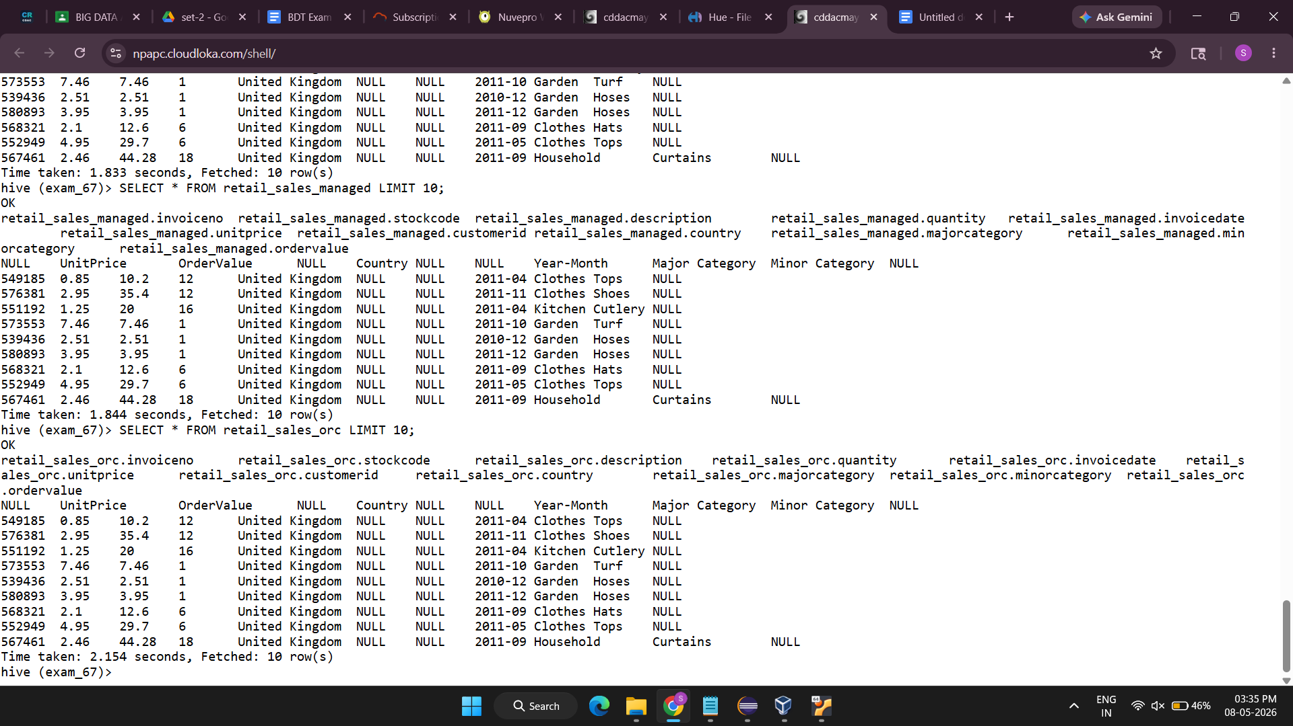
#Quary performance

SELECT COUNT(*) FROM retail_sales_managed;

SELECT COUNT(*) FROM retail_sales_orc;
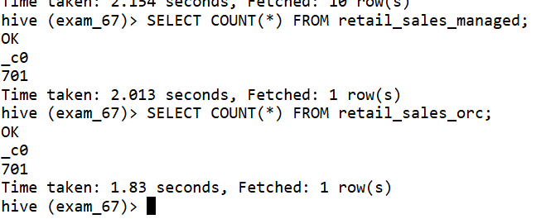

Tab 4
QUESTION 3 : PYSPARK DATAFRAME OPERATIONS

from pyspark.sql import SparkSession
from pyspark.sql.functions import col, sum, count

# CREATE SPARK SESSION

spark = SparkSession.builder \
.appName("RetailSalesDF") \
.getOrCreate()

LOAD CSV FILE INTO DATAFRAME

df = spark.read.csv(
"ecom_data.csv",
header=True,
inferSchema=True
)
# Display Schema
df.printSchema()

1. TOP MAJOR CATEGORIES BY TOTAL ORDER VALUE

top_major_categories = df.groupBy("MajorCategory") \
.agg(sum("OrderValue").alias("Total_OrderValue")) \
.orderBy(col("Total_OrderValue").desc()) \
.limit(5)

# Display Result
print("Top 5 Major Categories by Total Order Value")
top_major_categories.show()

2. TOP MINOR CATEGORIES BY PRODUCT COUNT
top_minor_categories = df.groupBy("MinorCategory") \
.agg(count("*").alias("Total_Orders")) \
.orderBy(col("Total_Orders").desc()) \
.limit(5)

# Display Result
print("Top 5 Minor Categories by Product Count")
top_minor_categories.show()

spark.stop()
